David Michael Slater
Press kit | October 2026
Fiction, nonfiction, theater - for children, teens, and adults.

David Michael Slater writes across sharply different audiences and tones. His work includes playful picture books, comic chapter-book adventures, unsettling fantasy, dark family novels, and nonfiction that questions familiar assumptions about schools and public life. His books often return to the power of language, moral choices, and the ways people respond to authority. He is also a musical-theater librettist and fiction editor of JUDITH MAGAZINE.

At a glance
Based in: Lake Oswego, Oregon
Books: More than forty, for children, teens, and adults
Background: Thirty years teaching in public schools
Editorial work: Fiction editor, JUDITH MAGAZINE
Recognition: The Vanishing won the American Writing Awards' 2022 Fiction Book of the Year. It was optioned for film by Chris Columbus's 26th Street Pictures in 2023.
UK edition: The Vanishing will be published as The Invisible Girl by Black Spring Press Group on December 2, 2027.
david@davidmichaelslater.com
www.davidmichaelslater.com

Author biographies
Biographies for event listings, interviews, and editorial coverage.

One sentence
David Michael Slater writes fiction, nonfiction, and theater for children, teens, and adults, and lives in Lake Oswego, Oregon.

Short biography
David Michael Slater is the author of more than forty books for children, teens, and adults. His work ranges from playful picture books and fantasy adventures to dark comic novels and nonfiction about education and public life. The Vanishing won the American Writing Awards' 2022 Fiction Book of the Year and was optioned for film by Chris Columbus's 26th Street Pictures in 2023. A retired public school teacher, Slater lives in Lake Oswego, Oregon.

Extended biography
David Michael Slater is the author of more than forty books for children, teens, and adults. His fiction includes the multigenerational tragicomedy UGLY, the Jewish coming-of-age novel Fun & Games, the historical fantasy The Vanishing, and the YA thriller Sparks. His books for children include The Boy & the Book, Cheese Louise!, and the Mysterious Monsters series. His nonfiction includes We're Doing It Wrong and Wingnuts.
The Vanishing won the American Writing Awards' 2022 Fiction Book of the Year and was optioned for film by Chris Columbus's 26th Street Pictures in 2023. Its UK edition, titled The Invisible Girl, is forthcoming from Black Spring Press Group on December 2, 2027.
Slater serves as fiction editor of JUDITH MAGAZINE. He also wrote the libretto and co-created the story for SHOCKED, a musical about Stanley Milgram and his obedience experiments, with composer and lyricist Ernest Ebell. He taught in public schools for thirty years before retiring. Born and raised in Pittsburgh's Squirrel Hill neighborhood, he now lives in Lake Oswego, Oregon.

Selected fiction
A selection for adult and teen readers. Full descriptions, samples, and buying links are on each book page.
UGLY
Adults | Tragicomedy and family saga
Three generations of women move from a London orphanage to a Michigan finishing school and 1980s Hollywood in a darkly comic story of beauty, power, and defiance.
Audiobook narrated by Lauren Irwin, released by HighBridge Audio.
Library Tales Publishing; distributed by Simon & Schuster | ISBN 9798894410043
Book details and editions
The Vanishing
Teens and adults | Historical fantasy
A Jewish girl becomes invisible after a traumatic loss and turns her new power toward resistance and the rescue of her closest friend in Nazi Europe.
UK edition: The Invisible Girl, Black Spring Press Group, December 2, 2027.
Library Tales Publishing; distributed by Simon & Schuster | ISBN 9798894410210
Intense Holocaust themes; may not suit younger or highly sensitive readers.
Book details and editions
Fun & Games
Adults | Dark comedy and coming of age
In the 1980s, Jonathan Schwartz tries to survive adolescence in a family whose outrageous behavior conceals faith, grief, secrets, and fear. A revised 10th anniversary edition is available.
Library Tales Publishing; distributed by Simon & Schuster | ISBN 9798894410180
Book details and editions
Sparks
Teens | Speculative thriller
A teenager who believes his bones could shatter at any moment and an imprisoned heiress uncover a conspiracy linking a brutal orphanage to a neighboring mansion.
Fitzroy Books / Regal House Publishing | ISBN 9781646031733
Book details and editions
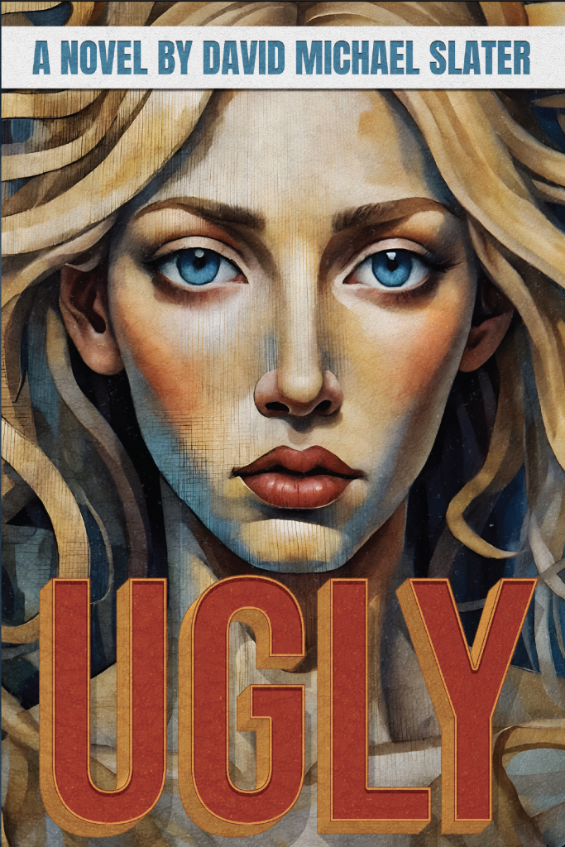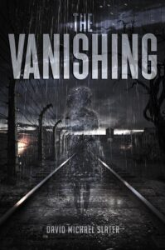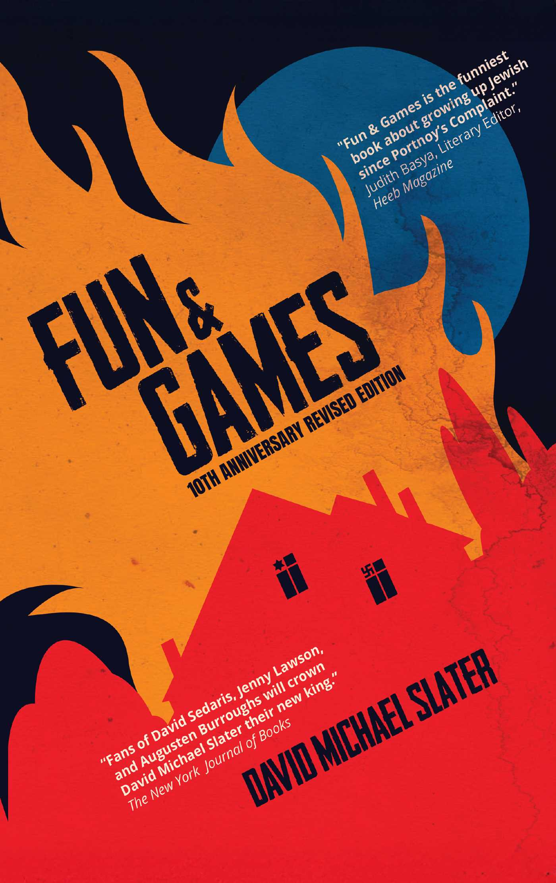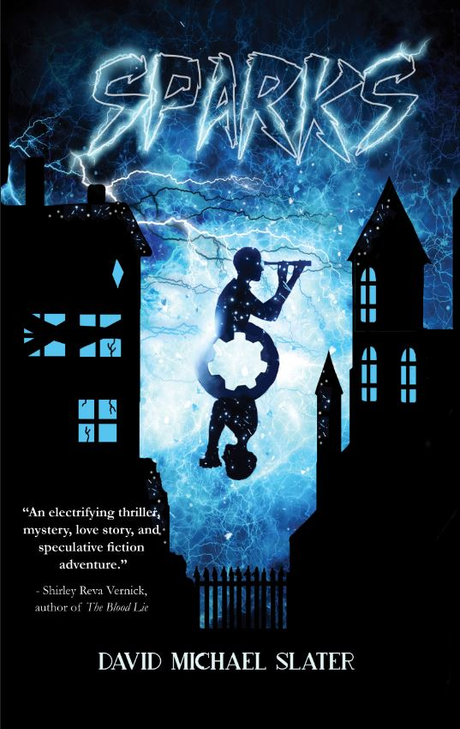

More books and theater
Representative work across younger readers, public life, and the stage.
The Boy & the Book
Children | Wordless picture book
An enthusiastic little boy and a library book develop an unexpected relationship in a story told through pictures.
Charlesbridge | Illustrated by Bob Kolar
Book details and editions
Bigfoot!
Children | Early chapter book
The Mattigan siblings search for a creature their famous father insists cannot exist. The first of six funny, mysterious adventures.
Incorgnito Publishing Press | Mysterious Monsters, Book 1
Book details and editions
We're Doing It Wrong
Nonfiction | Education
A teacher examines twenty-five familiar ideas in education, asking how they fail students and how schools could change.
Skyhorse Publishing
Book details and editions
Wingnuts
Nonfiction | Politics and public life
A field guide to everyday extremism that challenges readers across the political spectrum to reconsider how they argue and what they believe.
Sunbury Press
Book details and editions
SHOCKED
Theater | A new musical in development
A musical inspired by Stanley Milgram's obedience experiments, exploring conscience, authority, and ordinary people's choices under pressure. Libretto by David Michael Slater; music and lyrics by Ernest Ebell; story co-created by Slater and Ebell.
Official SHOCKED website
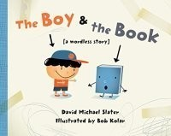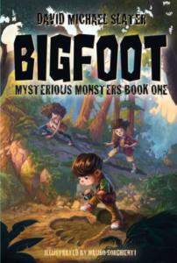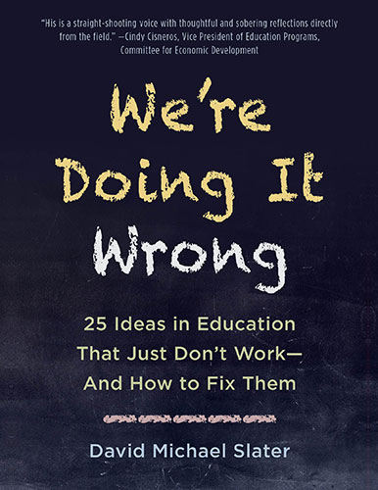

Interview topics and press links
Suggested starting points for conversations with David.
Writing across audiences
How do you decide whether a story belongs to children, teens, or adults, and what changes when you write for each?
Humor and difficult subjects
How do you find the point where a joke can reveal something painful without making light of it?
Fantasy and historical memory
How did growing up across from Pittsburgh's Tree of Life synagogue shape The Vanishing, and why tell this story through magical realism?
Thirty years in classrooms
Which assumptions about education did your teaching experience lead you to question?
Jewish stories and literary community
How do Jewish identity, memory, and your work at JUDITH MAGAZINE inform the stories you tell and publish?
Obedience on the stage
What drew you to Stanley Milgram, and what can musical theater bring to the question of why people obey?

Selected coverage
Jewish Review - A conversation about UGLY and its three generations of women.
Kirkus Reviews - Review of The Vanishing, September 2022.
Education Week - A teacher's view of We're Doing It Wrong, August 2018.
KOLO Morning Break - Television interview about The Vanishing and its film option, July 2023.
Deadline - Report on the 2023 film option for The Vanishing.

Photos and covers
The accompanying media folder includes the current author portrait, selected book covers, a SHOCKED poster, and plain-text biographies. For alternate images, credits, interviews, or review-copy requests, contact David directly.
david@davidmichaelslater.com

David on writing
Selected responses from interviews prepared for Library Tales Publishing in June 2025. Answers are excerpted from David's original replies.
What led you to write The Vanishing?
I grew up directly (diagonally) across the street from the Tree of Life Synagogue. Shortly after the murders there, I was asked by an old friend to write a reaction piece for the AP, but I guess writing it wasn't enough to help me cope with something so devastating having hit so close to home. I began The Vanishing shortly afterward.
Do you outline your novels?
I'm a 'pantser' (as opposed to a 'plotter'), meaning I don't outline my books before writing them (i.e., I 'fly by the seat of my pants'). I figure out the plots as I go--a process that requires lots of backtracking in order to move ahead.
How do you approach dark humor?
John Irving is my role model for walking that tightrope, specifically The World According to Garp. I recently heard him say in an interview that in his work, "things are funny right up to the point they aren't," and that struck a chord with me about how I approach dark humor. I guess it's also reflective of my worldview in general.
What do you hope readers take from UGLY?
As with most of my books, I hope readers laugh, cry, and think about some aspects of life just a little bit differently.

Selected praise
“A darkly comic and chaotic journey across three generations, UGLY will blindside you with clever (and deeply morbid) twists.”
Jason Pargin, author of John Dies at the End, on UGLY
“A tense and spellbindingly gripping fantasy meditation on the horrors of the Holocaust.”
Kirkus Reviews, on The Vanishing
More reviews and endorsements on the book pages

